Module 3 Part III - Predictive Analytics using Generative AI

By the end of this handout, you will be able to:
- Use Generative AI to analyze owned social media content.
- Review social media posts and identify clear themes (i.e., Manual Coding).
- Use Gemini to label each post according to the themes you manually identified.
- Use Gemini to identify themes and classify the content accordingly (e.g., AI Model Coding).
- Execute predictive analytics by comparing content type and average engagement.
- Visualize your findings.

Log in to Google Gemini using your UGA email. If you are logged in to your Google Account, you will also be logged in to Gemini as a Google user. You will have to log out, and log in again with your UGA account. UGA gives you access to a premium version of Gemini.

After logging in, make sure you select the “Pro” model on Gemini:
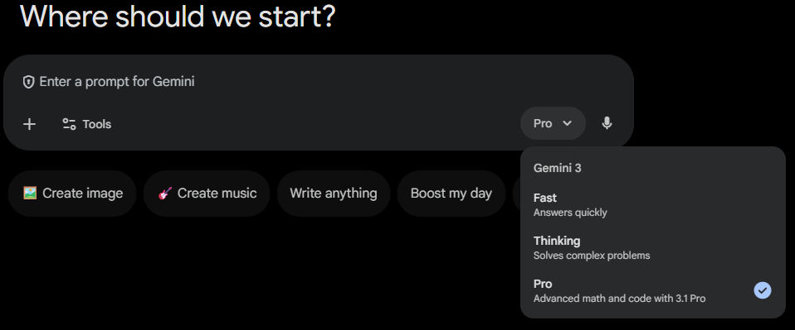

Part 0 - Preparation & Create Theme classification file
- From Module 3 Part I: Save the file as CSV if it is in an Excel format.
- Prepare the mutually exclusive list of post themes (e.g., Policy/Legal, Donations, Racial/LGBTQ+ Justice, Human Rights, Solidarity) from Module 3 Part II.
- Upload the CSV file with your owned data to Gemini and run the Prompt 0.
Prompt 0: copy-paste to Gemini:

I will upload a CSV of social posts. You are a social media analyst to help me accomplish the tasks I request in this chat.
- Use ONLY the “Full Text” column to classify each post into EXACTLY one of these themes:
[Donations; Human Rights; Policy/Legal; Refugees; Starvation] (Replace the examples with your themes identified in Module 3 Part II )
- Use existing columns only; DO NOT invent new metrics.
- If “Full Text” is empty, classify as N/A.
- Do NOT change the original text.

Tasks:
1) Output a CSV with columns:
Post ID (use row number starting at 1), Full Text, Theme (Manual List)
2) Name the output: “classified_manual_themes.csv”

Part A - Predictive analytics using themes that you identified (i.e., Manual Coding)
- Prompt A1 - Theme x Volume. copy‑paste to Gemini:
Use “classified_manual_themes.csv” you created.
Rules:
- Use existing columns only; DO NOT invent new metrics.
- Provide the underlying count table used for the bar chart.
Tasks:
1) Create a count table:
Theme (Manual List) × Volume (COUNT of posts)
2) Create a bar chart:
x=Theme, y=Volume
Put “n=COUNT” inside each bar.
Fill bars with different colors.
3) Name outputs clearly:
- Table: “manual_theme_volume_table.csv”
- Chart: “manual_theme_volume.png”

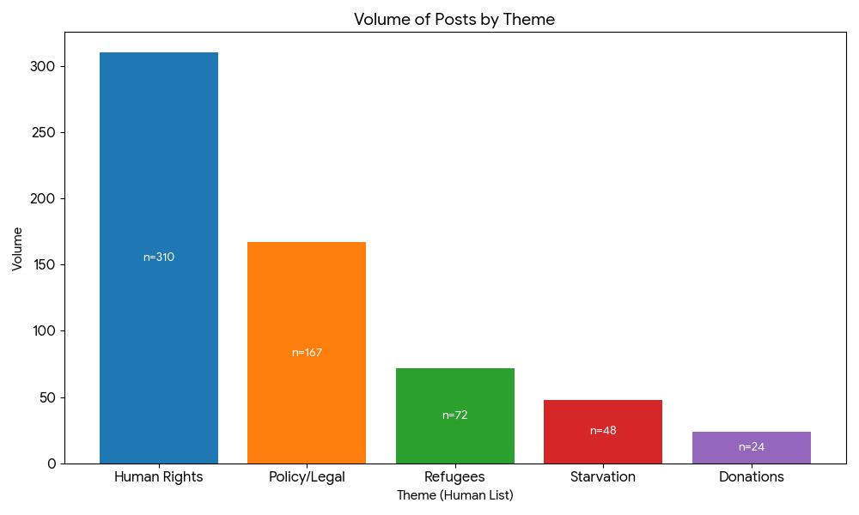

Tips: If the chart generated by Gemini does not look good, ask Gemini to adjust it based on your requirements. If it still does not meet your expectations, export the data to Canva or Excel and create your own graph.

Ask Gemini to show 5 examples of posts for each theme.
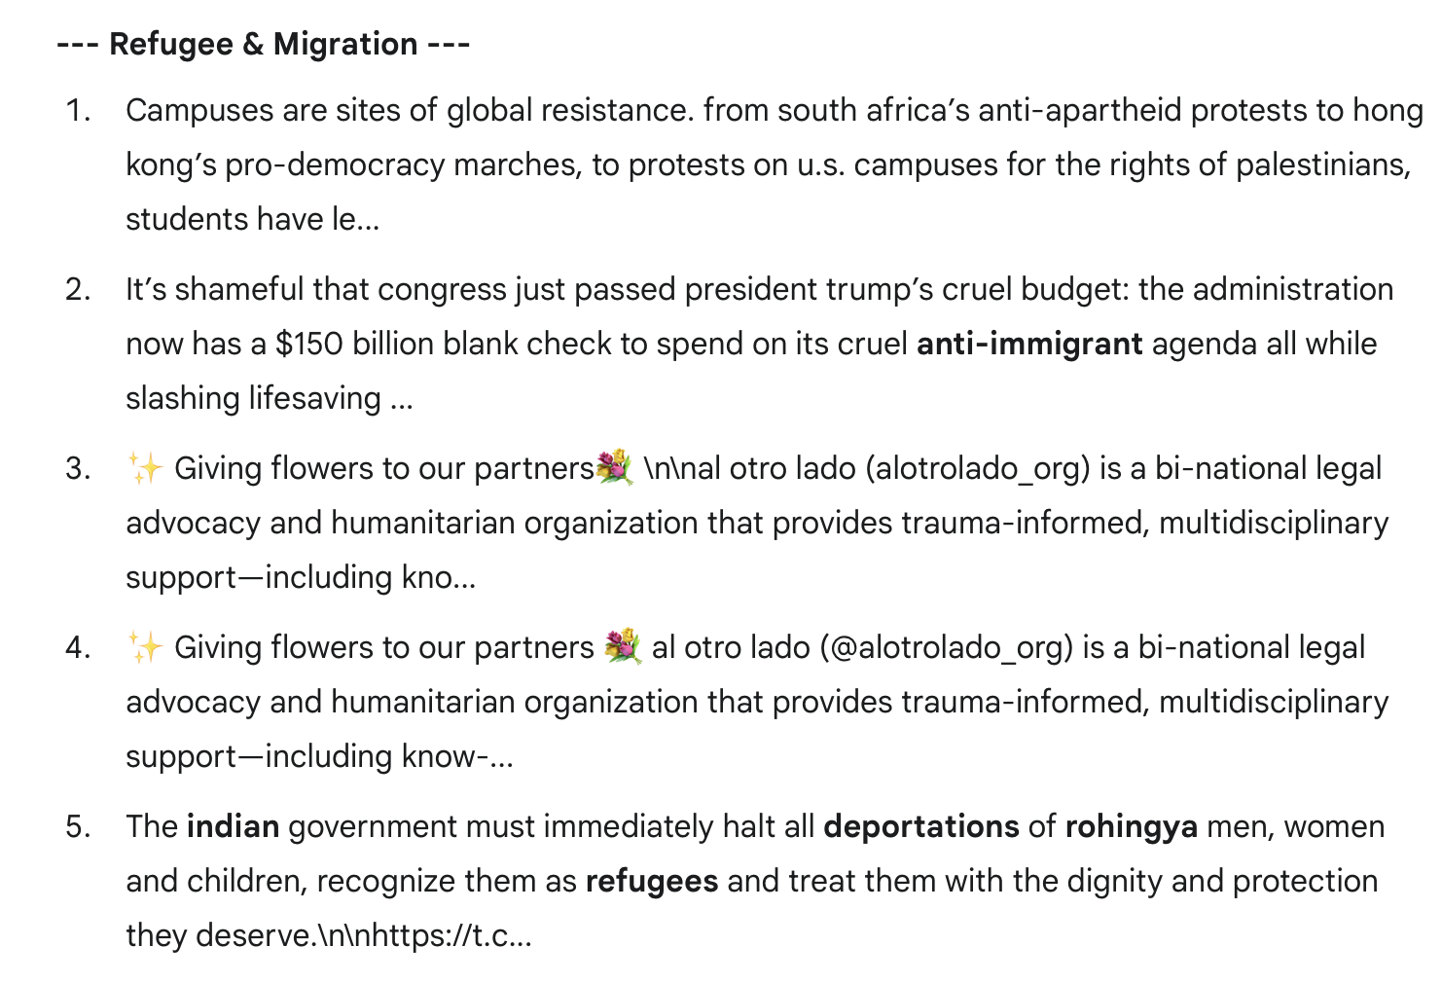
Review the results to ensure accurate classification.

- Prompt A2 Theme x Volume x Platform: copy‑paste to Gemini:
Use “classified_manual_themes.csv” you created.

Rules:
- Use existing columns only; DO NOT invent new metrics.
- Use ONLY the “Page Type” column to identify social media platforms.
- Provide the underlying count table used for the chart(s).

Tasks:
1) Create a cross-tab count table:
Theme (Manual List) × Page Type × Volume (COUNT of posts)
2) Create a bar chart:
Option A (preferred if Page Type has ≤ 4 unique values):
grouped bars where x=Theme, groups=Page Type, y=Volume
Option B (if Page Type has > 4 unique values):
create ONE chart per Page Type where x=Theme, y=Volume
3) Labeling:
Put “n=COUNT” inside each bar.
Fill bars with iconic brand colors.
4) Name outputs clearly:
- Table: “manual_theme_volume_by_pagetype_table.csv”
- Chart(s): “manual_theme_volume_by_pagetype.png” (or one per Page Type)

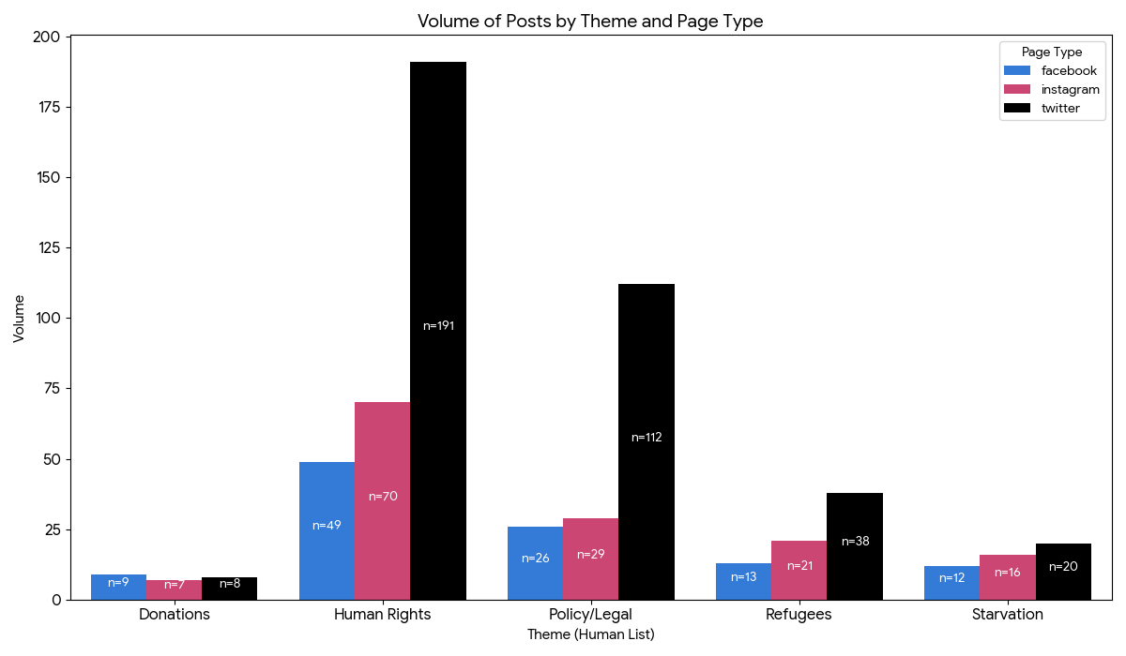

Tips: If the chart generated by Gemini does not look good, ask Gemini to adjust it based on your requirements. If it still does not meet your expectations, export the data to Canva or Excel and create your own graph.

- Prompt A3 Theme x Average Engagement Score: copy‑paste to Gemini:
Use “classified_manual_themes.csv” you created.
Rules:
- Use existing columns only; DO NOT invent new metrics.
- Calculate average engagement per theme using the "Engagement Score" column.
- Provide the underlying table used for the chart.
Tasks:
1) Create a summary table:
Theme (Manual List) ×
- Volume (COUNT)
- Average Engagement (MEAN of engagement metric)
2) Create a bar chart:
x=Theme, y=Average Engagement
Put “n=COUNT” inside each bar (COUNT is volume within theme).
Fill bars with iconic brand colors.
3) Name outputs clearly:
- Table: “manual_theme_avg_engagement_table.csv”
- Chart: “manual_theme_avg_engagement.png”

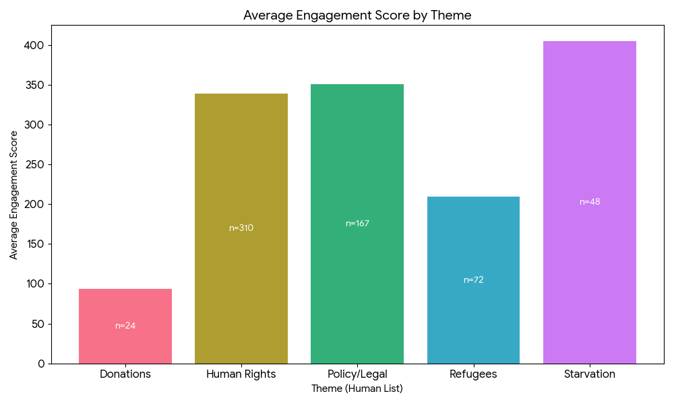

Tips: If the chart generated by Gemini does not look good, ask Gemini to adjust it based on your requirements. If it still does not meet your expectations, export the data to Canva or Excel and create your own graph.

- Prompt A4 Theme x Average Engagement x Platform: copy‑paste to Gemini:
Use “classified_manual_themes.csv” you created.

Rules:
- Use existing columns only; DO NOT invent new metrics.
- Use the same platform column selection logic as before:
Platform > Domain > Channel/Site (stop if none exist).
- Use the same engagement metric selection logic as before:
Engagement / Engagement Score / Total Engagement (stop if none exist).
- Provide the underlying table used for the chart(s).

Tasks:
1) Create a cross-tab summary table:
Theme (Manual List) × Platform ×
- Volume (COUNT of posts)
- Average Engagement (MEAN of engagement metric)
2) Create a bar chart:
Option A (preferred if <=4 platforms): grouped bars where
x=Theme, groups=Platform, y=Average Engagement
Option B (if many platforms): ONE chart per platform where
I will upload a CSV of social posts.

Rules:
- Use ONLY the “Full Text” column to identify themes.
- Create four to seven themes based on the texts.
- Theme names must be short and mutually exclusive (no overlap).
- For each theme, provide:
(a) a 1-sentence description
(b) 3 example keywords/phrases taken from the Full Text
- Do NOT use any other columns to create themes.
- Then classify each post into EXACTLY ONE of the themes you identified.

Tasks:
1) List the EXACT themes (with descriptions + example keywords/phrases).
2) Output a CSV with columns:
Post ID (row number starting at 1), Full Text, Theme (AI Discovered)

Name this output:
“classified_ai_themes.csv”

x=Theme, y=Average Engagement
3) Labeling:
Put “n=COUNT” inside each bar (COUNT is the theme-platform volume).
Fill bars with iconic brand colors.
4) Name outputs clearly:
- Table: “manual_theme_avg_engagement_by_platform_table.csv”
- Chart(s): “manual_theme_avg_engagement_by_platform.png” (or one per platform)

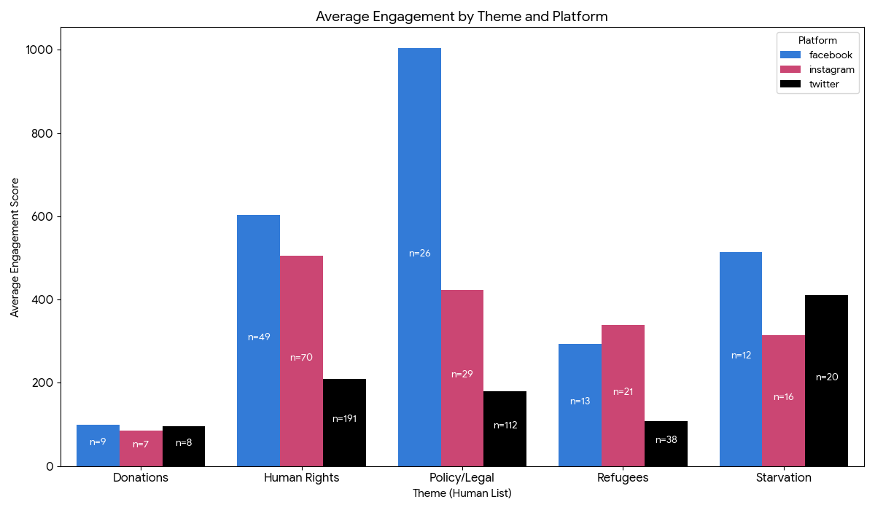

Part B - Predictive analytics using themes that Gemini identified (i.e., AI Model Coding)
In Part A, you used the themes you identified manually (i.e., Manual Coding).
In Part B, you will ask Gemini to identify themes based on the Full Text column (i.e., AI M model Coding) and then complete the predictive analytics accordingly.

- Prompt B0 Gemini-identified themes: copy‑paste to Gemini:
*** Before moving on to the next section, read through the AI-discovered themes. Check whether the descriptions and example keywords align with your understanding of the dataset. If they do, proceed to the next section; if not, ask Gemini to regenerate the theme(s) based on your knowledge of the posts.

*** After Prompt B0, copy the 5 theme names Gemini created and paste them into the bracketed list in each prompt below.
Use EXACT theme names, e.g.: [Theme 1; Theme 2; Theme 3; Theme 4; Theme 5]

- Prompt B1 Theme x Volume: copy‑paste to Gemini:
Rules:
- Use existing columns only; DO NOT invent new metrics.
- Provide the underlying count table used for the bar chart.
- Themes must be EXACTLY these:
[Gaza & Israel-Palestine Conflict; Death Penalty Abolition; Migrant Detention & Rights; Arbitrary Detention Cases; U.S. State Violence & Accountability; General Human Rights Mobilization] (Replace the examples with your Gemini-created themes)

Tasks:
1) Create a count table:
Theme (AI Discovered) × Volume (COUNT of posts)
2) Create a bar chart:
x=Theme, y=Volume
Put “n=COUNT” inside each bar.
Fill bars with different colors.
3) Name outputs exactly:
- Table: “ai_theme_volume_table.csv”
- Chart: “ai_theme_volume.png”

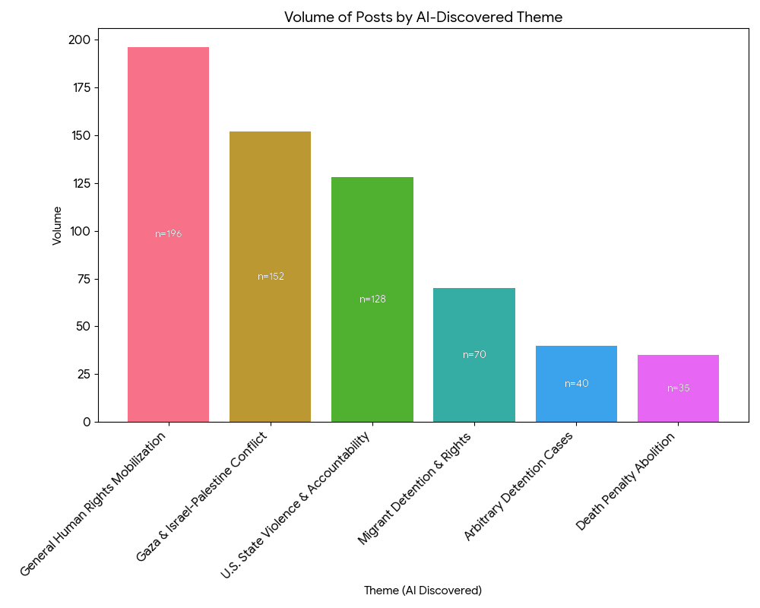

- Prompt B2 Theme x Volume x Platform: copy‑paste to Gemini:
Rules:
- Use existing columns only; DO NOT invent new metrics.
- Use ONLY the “Page Type” column to identify social media platforms.
- Provide the underlying count table used for the chart(s).
- Themes must be EXACTLY these:
[Gaza & Israel-Palestine Conflict; Death Penalty Abolition; Migrant Detention & Rights; Arbitrary Detention Cases; U.S. State Violence & Accountability; General Human Rights Mobilization] (Replace the examples with your Gemini-created themes)

Tasks:
1) Create a cross-tab count table:
Theme (AI Discovered) × Page Type × Volume (COUNT of posts)
2) Create a bar chart:
Option A (preferred if Page Type has ≤ 4 unique values):
grouped bars where x=Theme, groups=Page Type, y=Volume
Option B (if Page Type has > 4 unique values):
create ONE chart per Page Type where x=Theme, y=Volume
3) Labeling:
Put “n=COUNT” inside each bar.
Fill bars with iconic brand colors.
4) Name outputs exactly:
- Table: “ai_theme_volume_by_pagetype_table.csv”
- Chart(s): “ai_theme_volume_by_pagetype.png” (or one per Page Type)

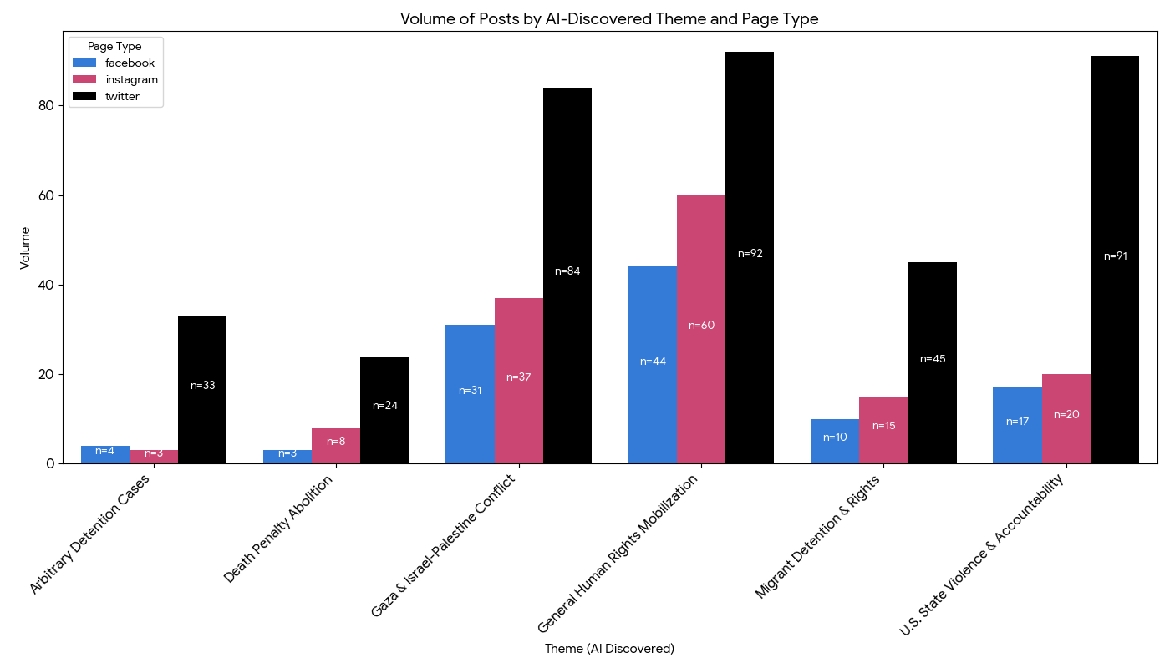

- Prompt B3 Theme x Average Engagement Score: copy‑paste to Gemini:
Rules:
- Use existing columns only; DO NOT invent new metrics.
- Use ONLY the “Engagement Score” column to compute engagement.
- Compute Average Engagement Score as the MEAN of “Engagement Score” for each theme.
- Provide the underlying summary table used for the chart.
- Themes must be EXACTLY these:
[Gaza & Israel-Palestine Conflict; Death Penalty Abolition; Migrant Detention & Rights; Arbitrary Detention Cases; U.S. State Violence & Accountability; General Human Rights Mobilization] (Replace the examples with your Gemini-created themes)

Tasks:
1) Create a summary table:
Theme (AI Discovered) ×
- Volume (COUNT of posts)
- Average Engagement Score (MEAN of Engagement Score)
2) Create a bar chart:
x=Theme, y=Average Engagement Score
Put “n=COUNT” inside each bar (COUNT = theme volume).
Fill bars with different colors.
3) Name outputs exactly:
- Table: “ai_theme_avg_engagementscore_table.csv”
- Chart: “ai_theme_avg_engagementscore.png”

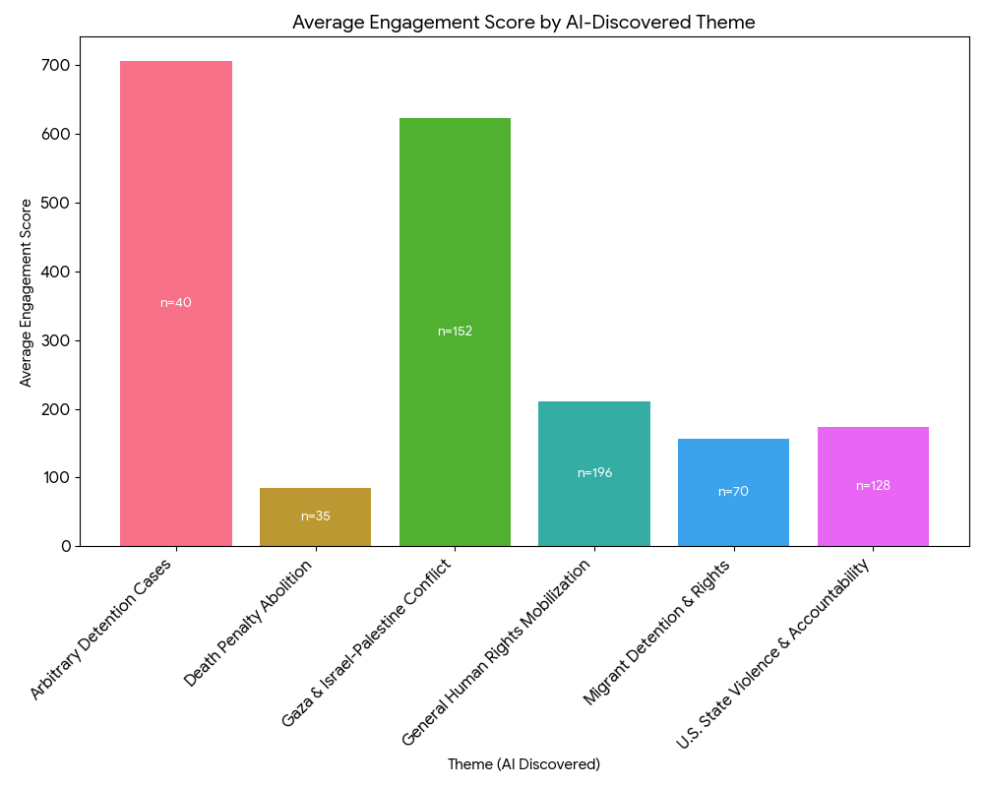

- Prompt B4 Theme x Average Engagement x Platform: copy‑paste to Gemini:
Rules:
- Use existing columns only; DO NOT invent new metrics.
- Use ONLY “Page Type” to identify social media platforms.
- Use ONLY “Engagement Score” to compute engagement.
- Compute Average Engagement Score as the MEAN of “Engagement Score”.
- Provide the underlying summary table used for the chart(s).
- Themes must be EXACTLY these:
[Gaza & Israel-Palestine Conflict; Death Penalty Abolition; Migrant Detention & Rights; Arbitrary Detention Cases; U.S. State Violence & Accountability; General Human Rights Mobilization] (Replace the examples with your Gemini-created themes)

Tasks:
1) Create a cross-tab summary table:
Theme (AI Discovered) × Page Type ×
- Volume (COUNT of posts)
- Average Engagement Score (MEAN of Engagement Score)
2) Create a bar chart:
Option A (preferred if Page Type has ≤ 4 unique values):
grouped bars where x=Theme, groups=Page Type, y=Average Engagement Score
Option B (if Page Type has > 4 unique values):
create ONE chart per Page Type where x=Theme, y=Average Engagement Score
3) Labeling:
Put “n=COUNT” inside each bar (COUNT = Theme×Page Type volume).
Fill bars with iconic brand colors.
4) Name outputs exactly:
- Table: “ai_theme_avg_engagementscore_by_pagetype_table.csv”
- Chart(s): “ai_theme_avg_engagementscore_by_pagetype.png” (or one per Page Type)
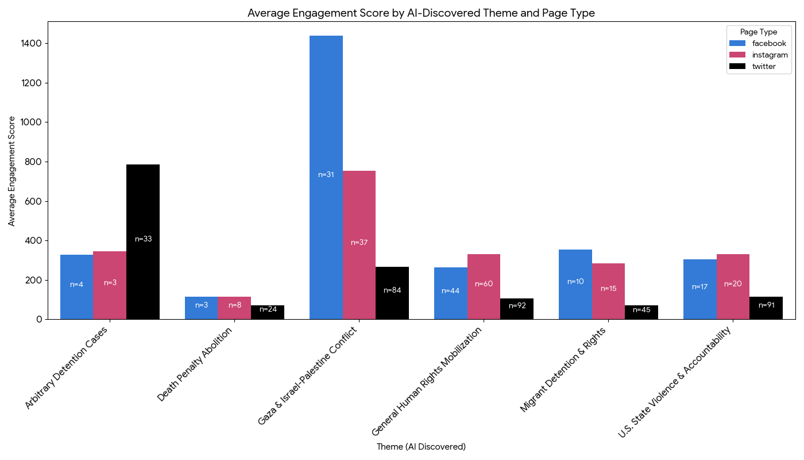

Part C - Predictive Analytics: Sentiment
- Prompt C1 Sentiment x Volume: copy‑paste to Gemini:
Rules:
- Use existing columns only; DO NOT invent new metrics.
- Use ONLY the “Sentiment” column for sentiment categories.
- If Sentiment has blanks/NA, treat them as “Neutral”.
- Provide the underlying count table used for the chart.

Tasks:
1) Create a count table:
Sentiment × Volume (COUNT of posts)
2) Create a bar chart:
x=Sentiment, y=Volume
Put “n=COUNT” inside each bar.
Fill bars with different colors ("Neutral"=grey; "Positive"=green; "Negative"=red).
3) Name outputs clearly:
- Table: “sentiment_volume_table.csv”
- Chart: “sentiment_volume.png”

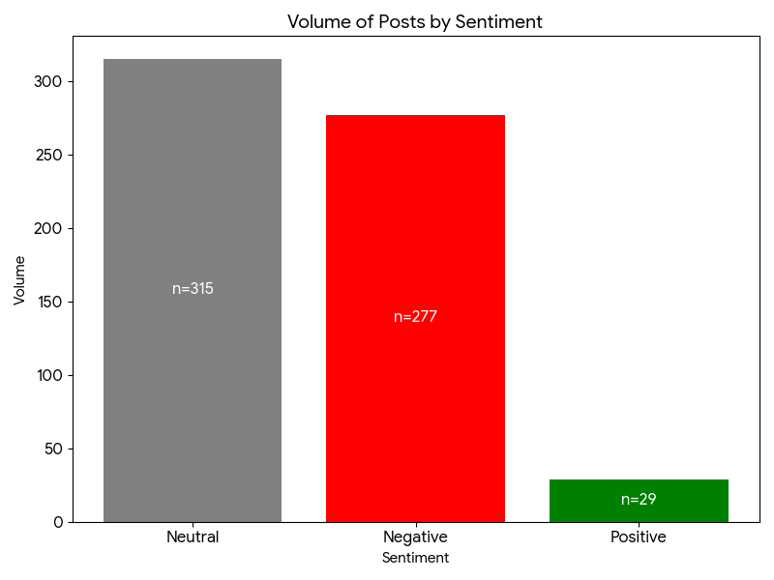

- Prompt C2 Sentiment x Volume x Platform (grouped bar): copy‑paste to Gemini:
Rules:
- Use existing columns only; DO NOT invent new metrics.
- Use ONLY the “Sentiment” column for sentiment categories.
- If Sentiment has blanks/NA, treat them as “Neutral”.
- Use ONLY the “Page Type” column to identify social media platforms.
- Provide the underlying count table used for the grouped bar chart.

Tasks:
1) Create a cross-tab count table:
Page Type × Sentiment × Volume (COUNT of posts)
2) Create a GROUPED bar chart:
x=Page Type, groups=Sentiment (Positive/Neutral/Negative), y=Volume
Put “n=COUNT” labels inside each bar (each bar count).
Use the specified colors for each Sentiment group.
3) Name outputs clearly:
- Table: “sentiment_volume_by_pagetype_table.csv”
- Chart: “sentiment_volume_by_pagetype_grouped.png”

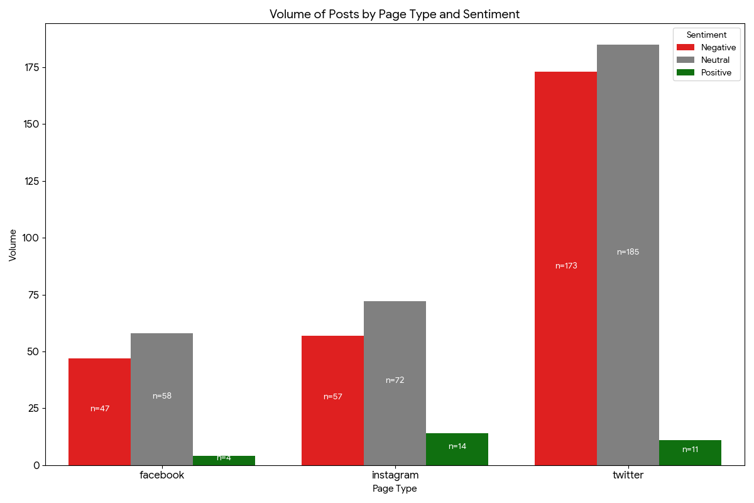

- Prompt C3 Sentiment x Average Engagement: copy‑paste to Gemini:
Rules:
- Use existing columns only; DO NOT invent new metrics.
- Use ONLY the “Sentiment” column for sentiment categories.
- If Sentiment has blanks/NA, treat them as “Neutral”.
- Use ONLY the “Engagement Score” column to compute engagement.
- Compute Average Engagement Score as the MEAN of “Engagement Score” within each sentiment.
- Provide the underlying summary table used for the chart.

Tasks:
1) Create a summary table:
Sentiment ×
- Volume (COUNT of posts)
- Average Engagement Score (MEAN of Engagement Score)
2) Create a bar chart:
x=Sentiment, y=Average Engagement Score
Put “n=COUNT” inside each bar (COUNT = sentiment volume).
Fill bars with different colors ("Neutral"=grey; "Positive"=green; "Negative"=red).
3) Name outputs clearly:
- Table: “sentiment_avg_engagementscore_table.csv”
- Chart: “sentiment_avg_engagementscore.png”

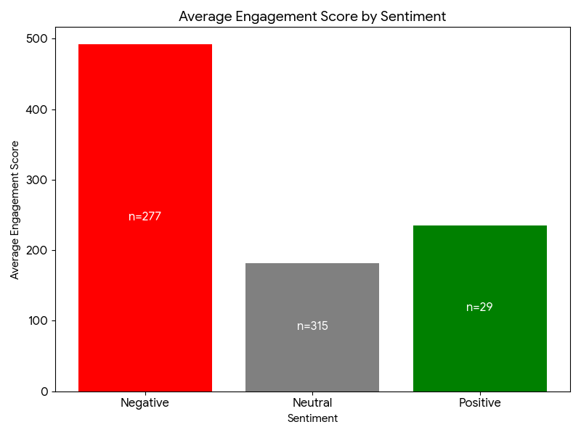

- Prompt C4 Sentiment x Average Engagement x Platform (grouped bar): copy‑paste to Gemini:
Rules:
- Use existing columns only; DO NOT invent new metrics.
- Use ONLY the “Sentiment” column for sentiment categories.
- If Sentiment has blanks/NA, treat them as “Neutral”.
- Use ONLY the “Page Type” column to identify social media platforms.
- Use ONLY the “Engagement Score” column to compute engagement.
- Compute Average Engagement Score as the MEAN of “Engagement Score”.
- Provide the underlying summary table used for the grouped bar chart.
Tasks:
1) Create a cross-tab summary table:
Page Type × Sentiment ×
- Volume (COUNT of posts)
- Average Engagement Score (MEAN of Engagement Score)
2) Create a grouped bar chart:
x=Page Type, y=Average Engagement Score
Grouped by Sentiment (each segment height = mean Engagement Score for that Page Type × Sentiment group)
Put “n=COUNT” labels inside each grouped segment (COUNT = posts in that Page Type × Sentiment group).
Use different colors for different Sentiment segments ("Neutral"=grey; "Positive"=green; "Negative"=red).
3) Name outputs clearly:
- Table: “sentiment_avg_engagementscore_by_pagetype_table.csv”
- Chart: “sentiment_avg_engagementscore_by_pagetype_grouped.png”

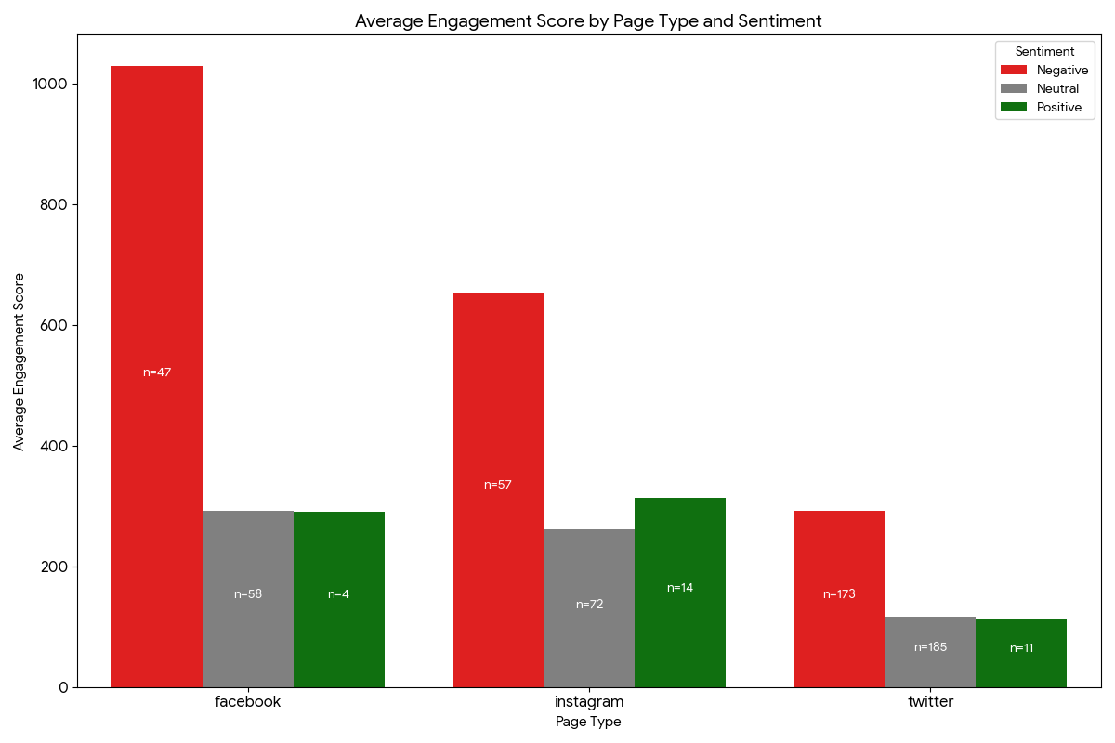
Part D - Predictive Analytics: Emotion
- Prompt D1 Emotion x Volume: copy‑paste to Gemini:
Rules:
- Use existing columns only; DO NOT invent new metrics.
- Use ONLY the “Emotion” column for emotion categories.
- If Emotion has blanks/NA, label them as “No Emotion/Unknown”.
- Provide the underlying count table used for the chart.

Tasks:
1) Create a count table:
Emotion × Volume (COUNT of posts)
2) Create a bar chart:
x=Emotion, y=Volume
Put “n=COUNT” inside each bar.
Fill bars with different colors.
3) Name outputs clearly:
- Table: “emotion_volume_table.csv”
- Chart: “emotion_volume.png”
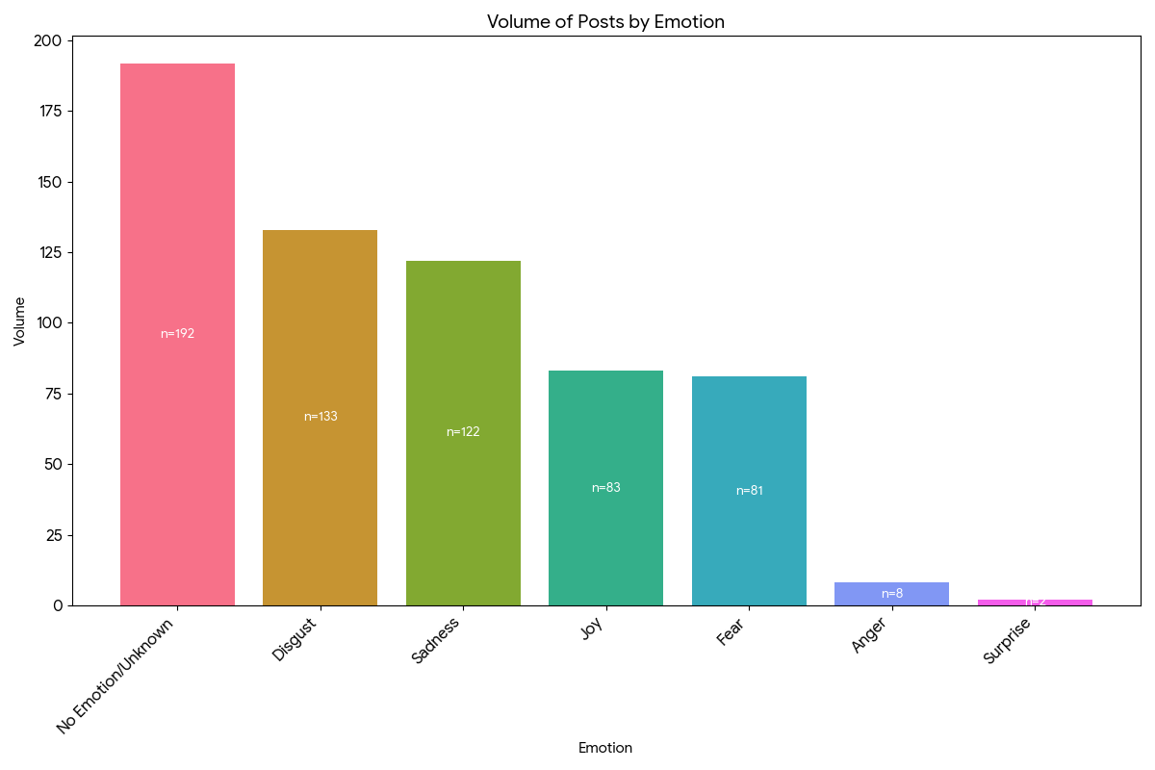

- Prompt D2 Emotion x Volume by Social Media Platform: copy‑paste to Gemini:
Rules:
- Use existing columns only; DO NOT invent new metrics.
- Use ONLY the “Emotion” column for emotion categories.
- If Emotion has blanks/NA, label them as “No Emotion/Unknown”.
- Use ONLY the “Page Type” column to identify social media platforms.
- Provide the underlying count table used for the charts.
Tasks:
1) Create a cross-tab count table:
Page Type × Emotion × Volume (COUNT of posts)
2) Create THREE separate bar charts (one per platform):
- For each of the three Page Type values with the highest total volume:
Create a bar chart with:
x=Emotion, y=Volume (COUNT of posts)
Put “n=COUNT” labels inside each bar.
Use different colors for different Emotion bars.
3) Name outputs clearly:
- Table: “emotion_volume_by_pagetype_table.csv”
- Charts:
“emotion_volume_platform1.png”
“emotion_volume_platform2.png”
“emotion_volume_platform3.png”
Also include a short note specifying which Page Type each “platform1/2/3” corresponds to.
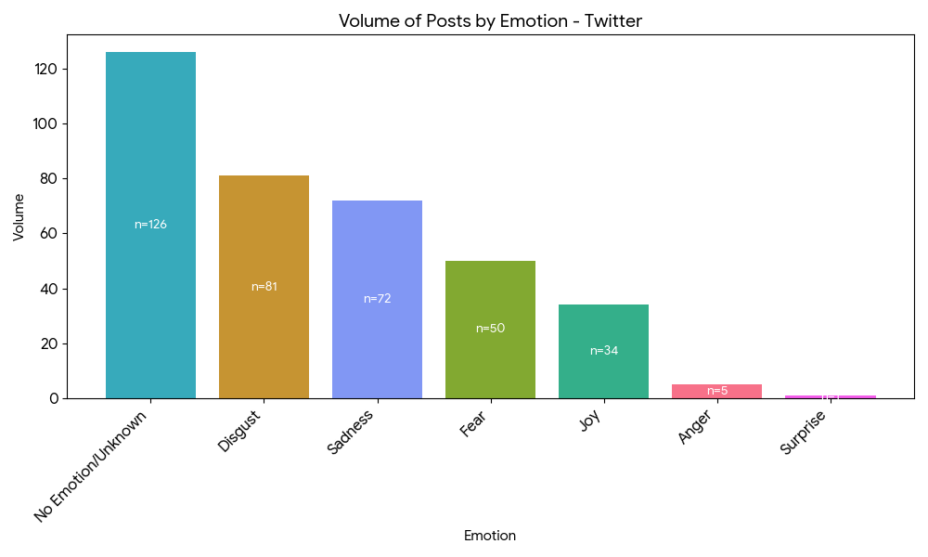

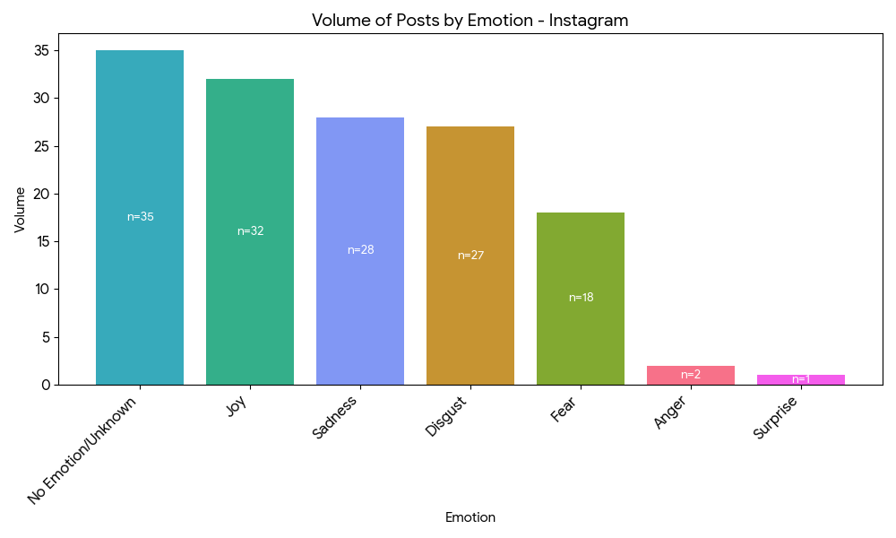

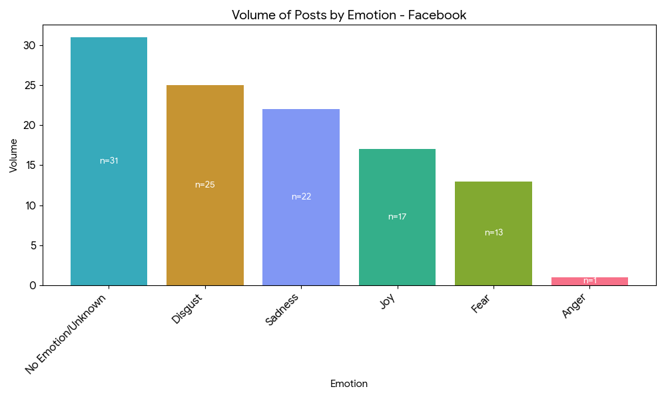

- Prompt D3 Emotion x Average Engagement: copy‑paste to Gemini:
Rules:
- Use existing columns only; DO NOT invent new metrics.
- Use ONLY the “Emotion” column for emotion categories.
- If Emotion has blanks/NA, label them as “No Emotion/Unknown”.
- Use ONLY the “Engagement Score” column to compute engagement.
- Compute Average Engagement Score as the MEAN of “Engagement Score” within each emotion.
- Provide the underlying summary table used for the chart.

Tasks:
1) Create a summary table:
Emotion ×
- Volume (COUNT of posts)
- Average Engagement Score (MEAN of Engagement Score)
2) Create a bar chart:
x=Emotion, y=Average Engagement Score
Put “n=COUNT” inside each bar (COUNT = emotion volume).
Fill bars with different colors.
3) Name outputs clearly:
- Table: “emotion_avg_engagementscore_table.csv”
- Chart: “emotion_avg_engagementscore.png”
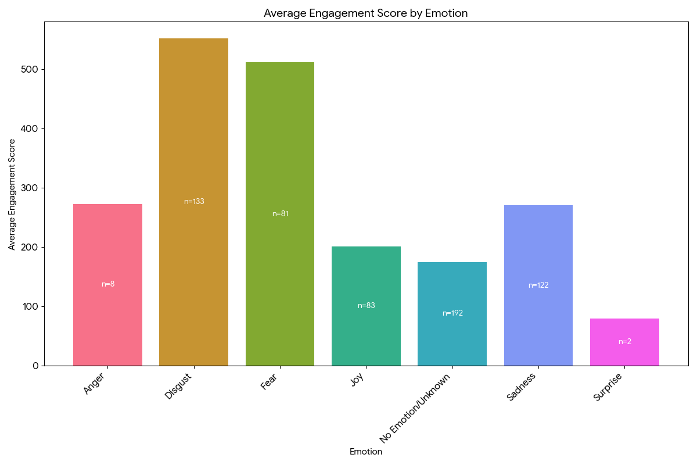

- Prompt D4 Emotion x Average Engagement by Social Media Platform: copy‑paste to Gemini:
Rules:
- Use existing columns only; DO NOT invent new metrics.
- Use ONLY the “Emotion” column for emotion categories.
- If Emotion has blanks/NA, label them as “No Emotion/Unknown”.
- Use ONLY the “Page Type” column to identify social media platforms.
- Use ONLY the “Engagement Score” column to compute engagement.
- Compute Average Engagement Score as the MEAN of “Engagement Score”.
- Provide the underlying summary table used for the charts.

Tasks:
1) Create a cross-tab summary table:
Page Type × Emotion ×
- Volume (COUNT of posts)
- Average Engagement Score (MEAN of Engagement Score)
2) Create THREE separate bar charts (one per platform):
- For each of the three Page Type values with the highest total volume:
Create a bar chart with:
x=Emotion, y=Average Engagement Score (MEAN of Engagement Score for that Page Type × Emotion group)
Put “n=COUNT” labels inside each bar (COUNT = posts in that Page Type × Emotion group).
Use different colors for different Emotion bars.
3) Name outputs clearly:
- Table: “emotion_avg_engagementscore_by_pagetype_table.csv”
- Charts:
“emotion_avg_engagement_platform1.png”
“emotion_avg_engagement_platform2.png”
“emotion_avg_engagement_platform3.png”
Also include a short note specifying which Page Type each “platform1/2/3” corresponds to.

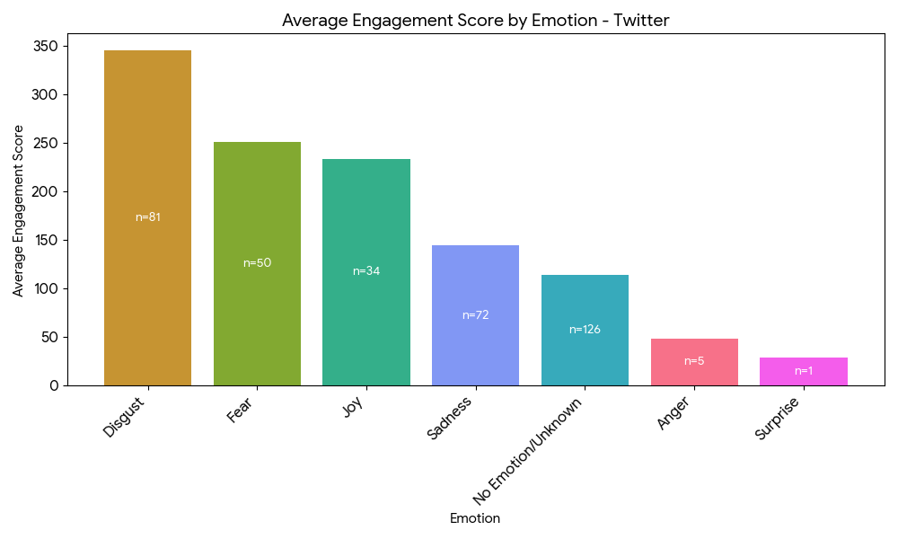

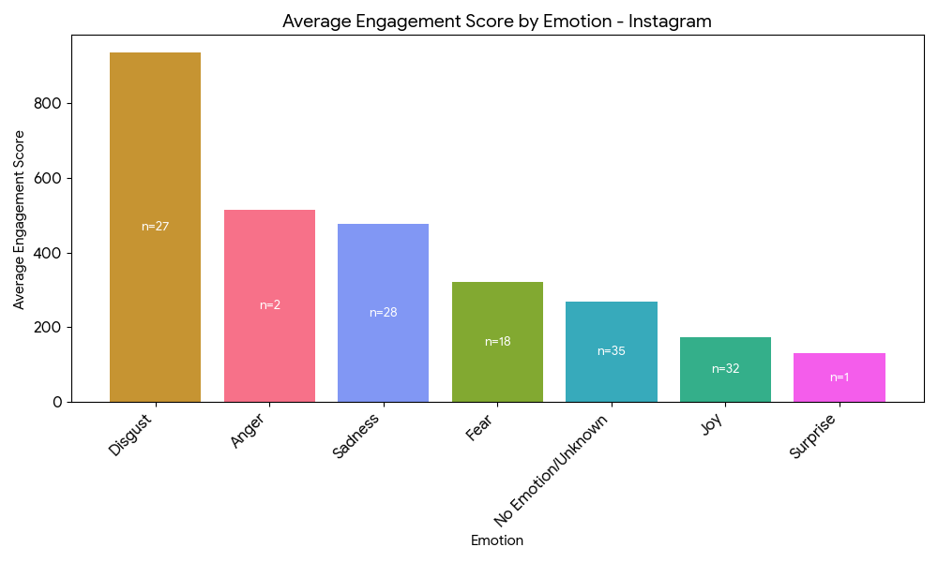

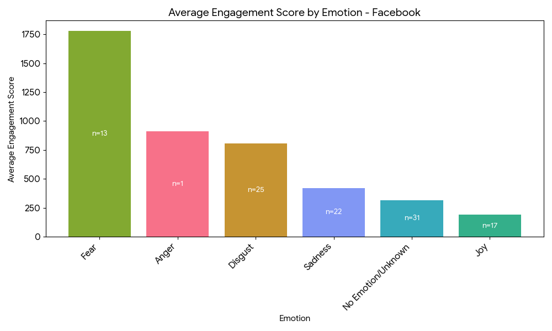

Deliverables: what goes to your assignment?

Graphs
- Carefully select the graphs that you want to include.
  - If your themes and Gemeini’s themes are practically identical, no need to include both.
- Note that the more advanced graphs (e.g., theme x average engagement x platform) already include data from earlier graphs (e.g., theme x average engagement, theme x volume).
- Try alternative graphs for your findings. E.g., breakdown of theme volume fits nicely into a pie chart, as it adds up to 100% of the data.
- Take data visualization to the next step! Ask Gemini to visualize the graph and its parts based on their content. E.g., the wedge of a pie chart representing the percentage of conversation about volunteering will include a volunteering-related graphic.
- Can’t get Gemini to do something? Try a different Gen AI to do it.

Context
- As with your earlier assignment, the narrative for each breakdown matters. Presenting a breakdown (i.e., bar graph and/or pie chart), include a summary of the posts and/or examples of posts. This will allow readers, and you, to better understand what the differences that you found mean and how to use them in the recommendations section.

Recommendations
- New recommendations: use the insights from the analysis to draw new recommendations.
- Strengthening existing recommendations: how do your findings here fit your earlier analysis and suggested recommendations? The goal is for your recommendations to be supported by several data points. Try to support recommendations from assignment 2 with data from this section.
- For instance, if you suggested in assignment 2 that your organization will post more about volunteering work because it was a large theme in the conversation, let’s find out if (a) your organization posts about it, and (b) if they do, do such posts trigger engagement.

